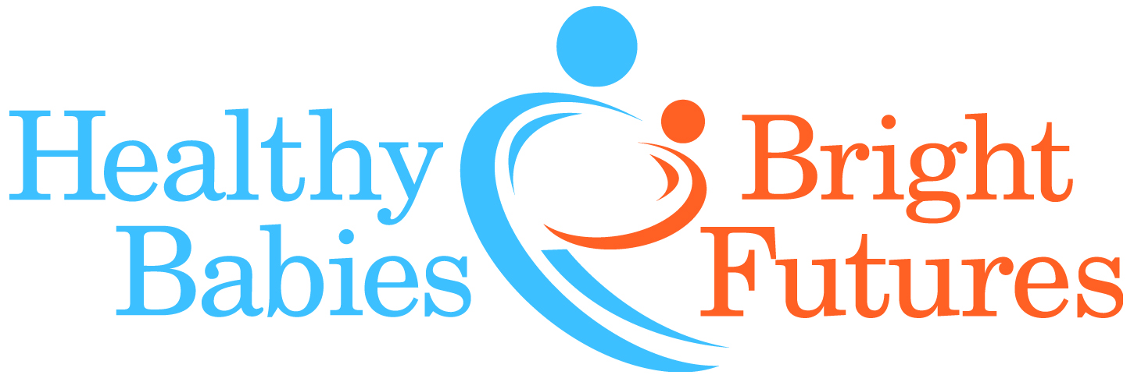

FOR IMMEDIATE RELEASE

MEDIA CONTACT:
David Zucker, dzucker@hbbf.org. 917.617.0584
AUDIO/VISUAL ASSETS: Phone and in-person interviews per spokesperson availability, widget, demonstration video, infographic, high-resolution images of water testing kit, spokespeople headshots, logos. All assets available here.
Lead in Water Action Kits Now Available to Detect and Reduce Exposure

Healthy Babies Bright Futures Partners with Virginia Tech to Protect American Families

New York, NY (February 17, 2016) – Healthy Babies Bright Futures (HBBF) is making Lead in Water Action Kits available to families across America so they can test their tap water for the presence of lead and take actions to reduce exposure. HBBF has partnered with Virginia Tech to offer an in-home kit that can detect most lead hazards in water. Each family’s water samples are sent for analysis to Virginia Tech’s lab - the same lab that uncovered lead contamination in Washington, DC and, most recently, in Flint, Michigan. The family then receives its test results along with a customized report that includes concrete actions the family can take to reduce lead exposure.

The ongoing problem with lead in drinking water was recently brought back to the nation’s attention with the crisis in Flint, Michigan. According to a poll conducted last week by ORC International* on behalf of Healthy Babies Bright Futures, Americans’ concern about lead in their own drinking water is highest among women (62%), parents of young children (69%), African Americans (75%) and Hispanic Americans (75%).

“We want to ensure that all Americans can drink tap water without worrying about lead contamination,” says HBBF Executive Director, Charlotte Brody, RN. “Every household, particularly those in low-income neighborhoods and in older homes where the risk is highest, needs to be able to test their water to see if they have a problem and, if they do, understand exactly what they can do to reduce their exposure.”

The only way to detect a hazard in a home’s tap water is to test the water coming out of the tap. Even water that is safe coming out of the local water utility might become contaminated with lead as it runs through lead service lines and plumbing that contains lead.

“This problem unfortunately goes well beyond Flint,” said Dr. Marc Edwards of Virginia Tech. “Our nation’s water infrastructure is aging and sometimes contains lead hazards. And there is no reliable source of data telling us where there’s a lead problem. This testing can be used to detect lead hazards in water and inform appropriate actions, if necessary, to reduce exposures.”

Health professionals and scientists now understand that there is no safe level of lead. The Centers for Disease Control and Prevention warns that, “Even low levels of lead in blood have been shown to affect IQ, the ability to pay attention and academic achievement.” The impact of exposure to lead on the brain is greatest during the first 1,000 days of development, so addressing the problem is most critical for pregnant women, those who are trying to become pregnant and families with children under two years of age.

The price for each test kit is $65, which covers the cost to HBBF including shipping the sample bottles to the lab at Virginia Tech and the analysis of the water samples. If a family cannot afford the full cost of a kit, there is an option for the family to pay what it can afford. Families may also choose to pay for other families’ kits. Anyone interested in ordering a lead in water action kit can click here.

HBBF will also provide an analysis of the national data from the test kit results to draw further attention to the issue of lead in water and to build support for individual and broader actions to fix the underlying problems. Participating families are not only solving their own lead exposure problems but are also helping to identify areas of risk across the country.

About Healthy Babies Bright Futures:

Healthy Babies Bright Futures is an alliance of non-profit organizations, philanthropies and scientists that designs and implements projects to reduce babies’ exposure to toxic chemicals during the most vulnerable and significant periods of development: in utero and from birth to age two.

*Results from an online survey conducted by ORC International among a sample of 1,026 adults, Feb. 11 – Feb. 14, 2016

